**Installation and Usage Guide**

**Anaconda Installation**

Note:

**Please use your personal laptops for installation. Anaconda Default is available for free to developers, students, teachers, academic institutions, and non-commercial open-source software projects. Therefore, it is not permissible to install it on your office or work PC.**

**About Anaconda**

* Anaconda is an open-source distribution of the programming languages Python and R. It comes with various packages related to machine learning and data science.
* The idea behind Anaconda is to simplify package management and deployment for data scientists.
* By installing Anaconda, you can easily get the Python interpreter along with essential data science libraries, making it convenient to work on projects without worrying about missing dependencies1.
* If you’re interested in scientific computing, machine learning applications, large-scale data processing, or predictive analytics, Anaconda is a great choice!

**Anaconda Installation Steps**

1. **Go to official page of Anaconda-** [**https://www.anaconda.com/**](https://www.anaconda.com/)

**Click free download on link.**



1. **Click on Skip Registration**

**( Go through privacy policy and terms of use carefully-**  [Privacy Policy](https://www.anaconda.com/privacy-policy) and [Terms of Service](https://legal.anaconda.com/policies/en/?name=terms-of-service#terms-of-service).)

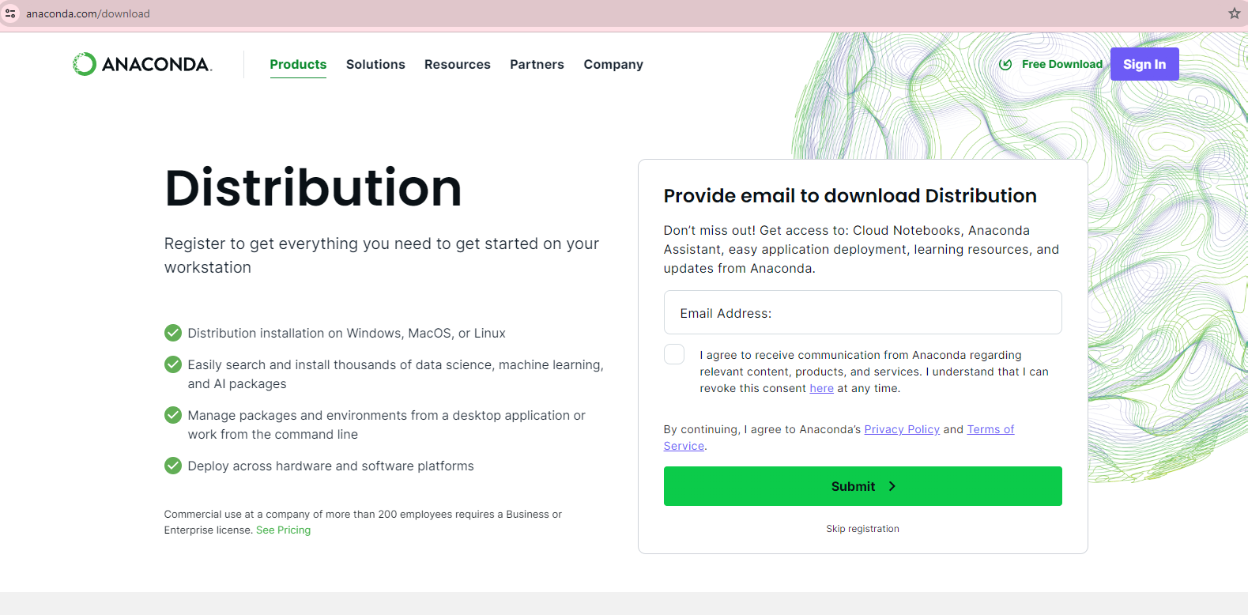

1. **Select relevant installer**

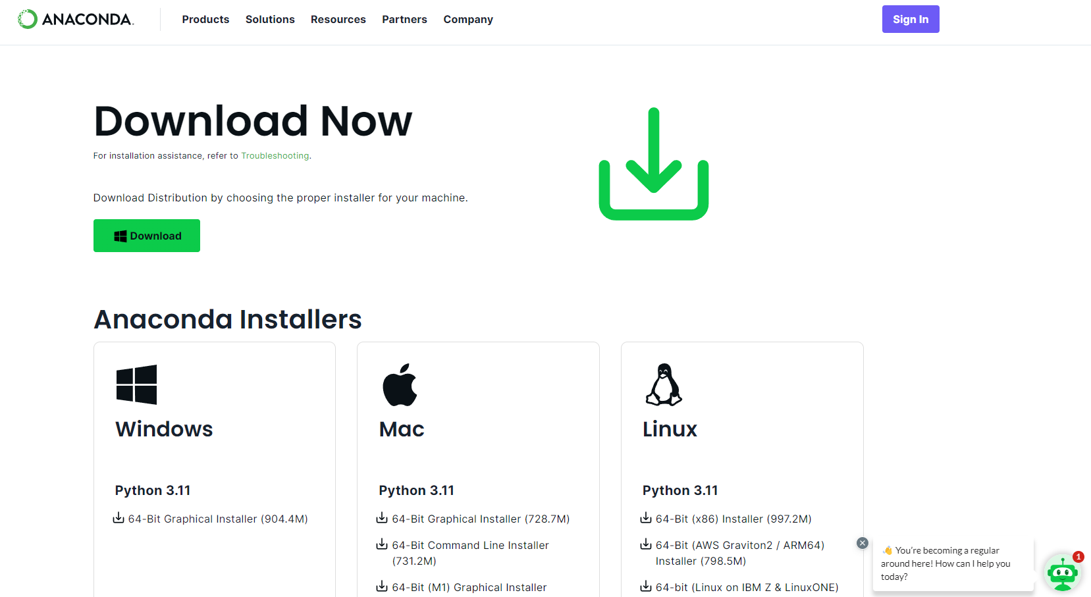

1. **Installer downloads in your system, follow installation by executing the download**

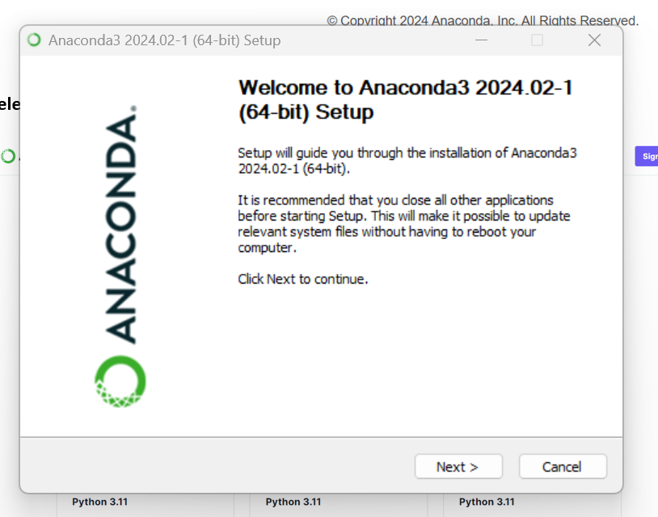

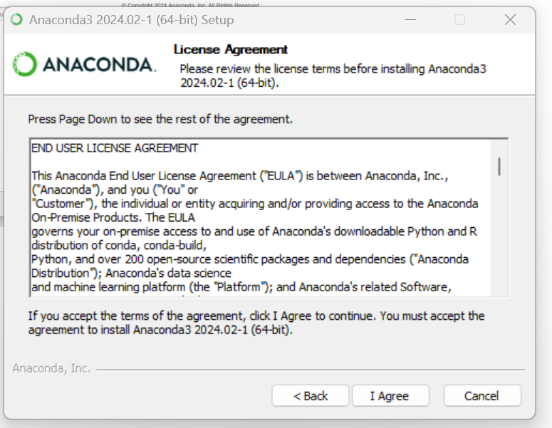

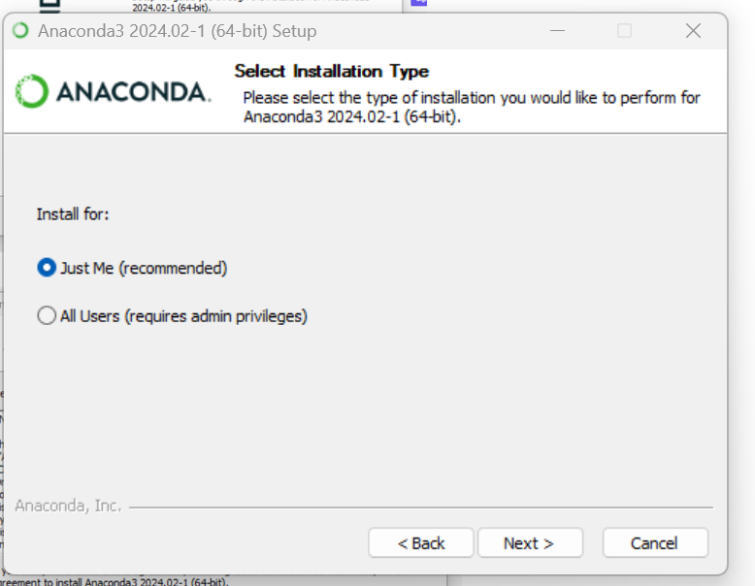

**Let the path be default:**

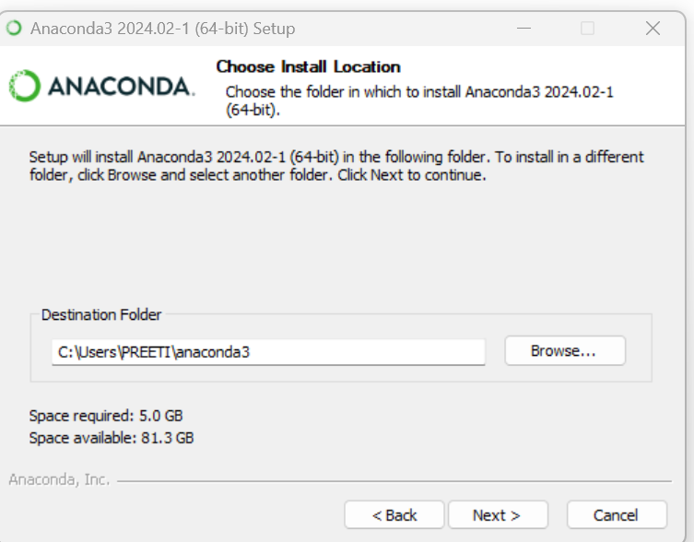

**Click next and proceed installation:**

**Ensure that all checkboxes are selected before clicking on Install button**

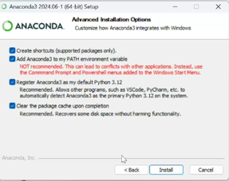

**It will take 15 to 30 minutes for the installation**

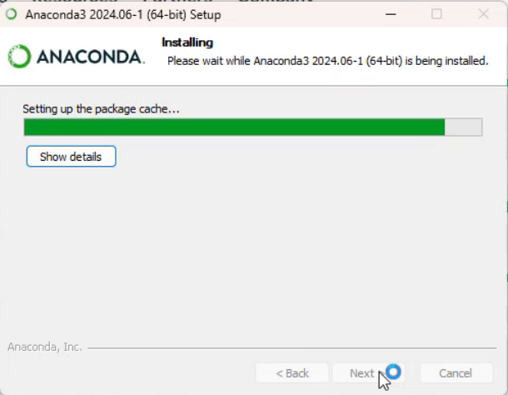

**Click in Next button after installation is completed**

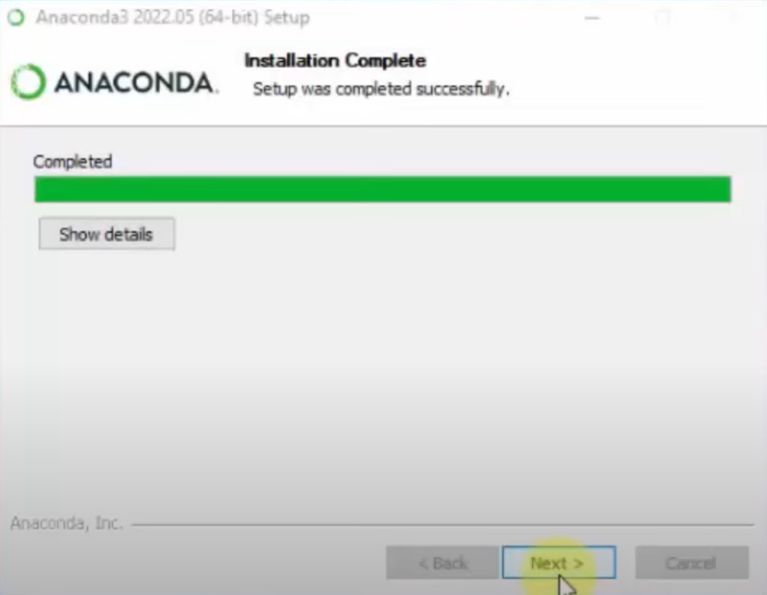

**Click on Next**

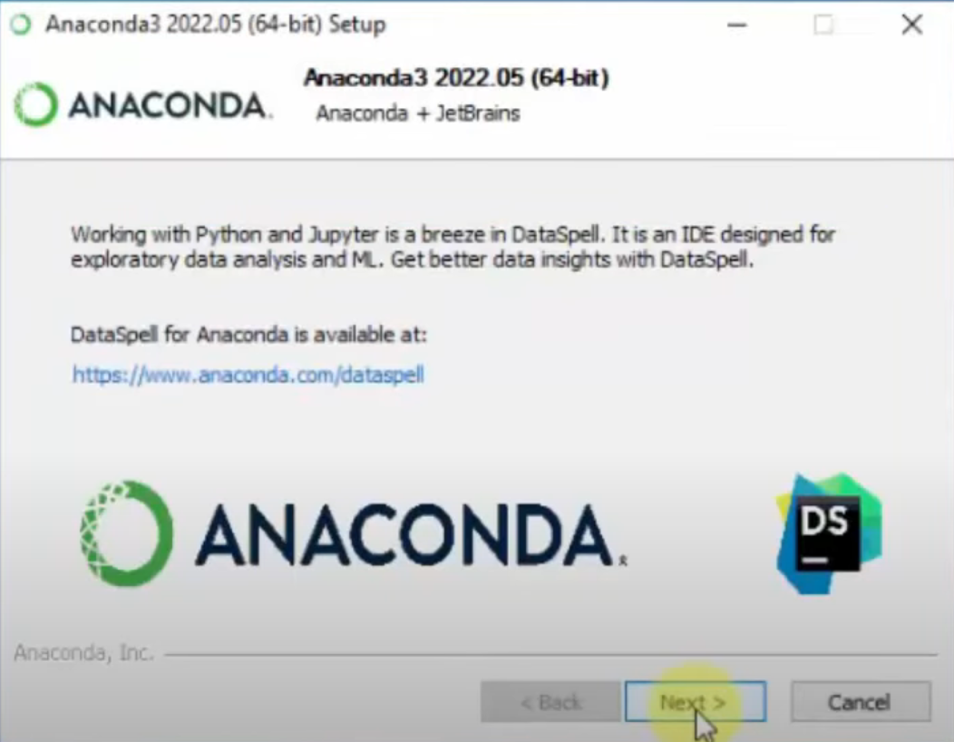

**Click on finish**

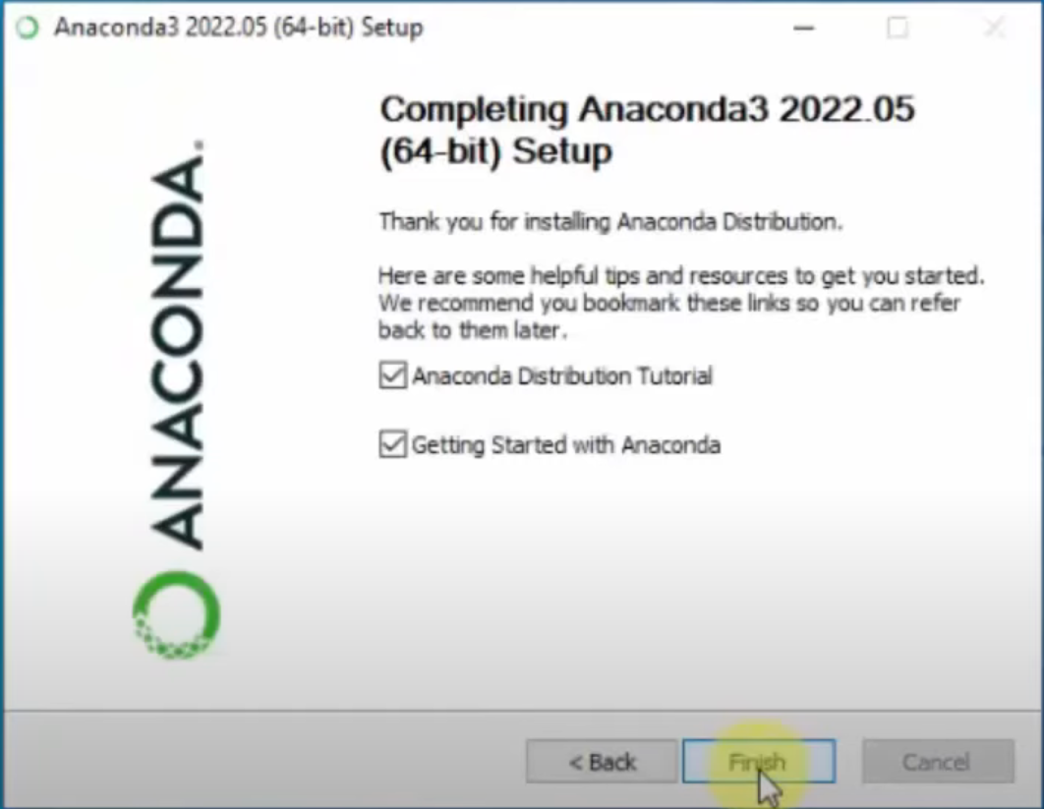

**Next Page – How to use Jupyter notebook**

**Jupyter Notebook**

* Jupyter Notebook is an open-source web application that allows you to create and share documents containing live code, equations, visualizations, and explanatory text.
* It provides a flexible and interactive environment for data analysis, experimentation, and collaboration.
* When you launch Jupyter Notebook, you’ll see an interface where you can create notebooks. These notebooks consist of cells that can contain either code or formatted text.

Jupyter Notebook may be used within Anaconda environment because Anaconda provides a convenient way to install Jupyter and manage dependencies

**Steps to open Jupyter Notebook on your system:**

1. **Search and open Jupyter Notebook app on your system**

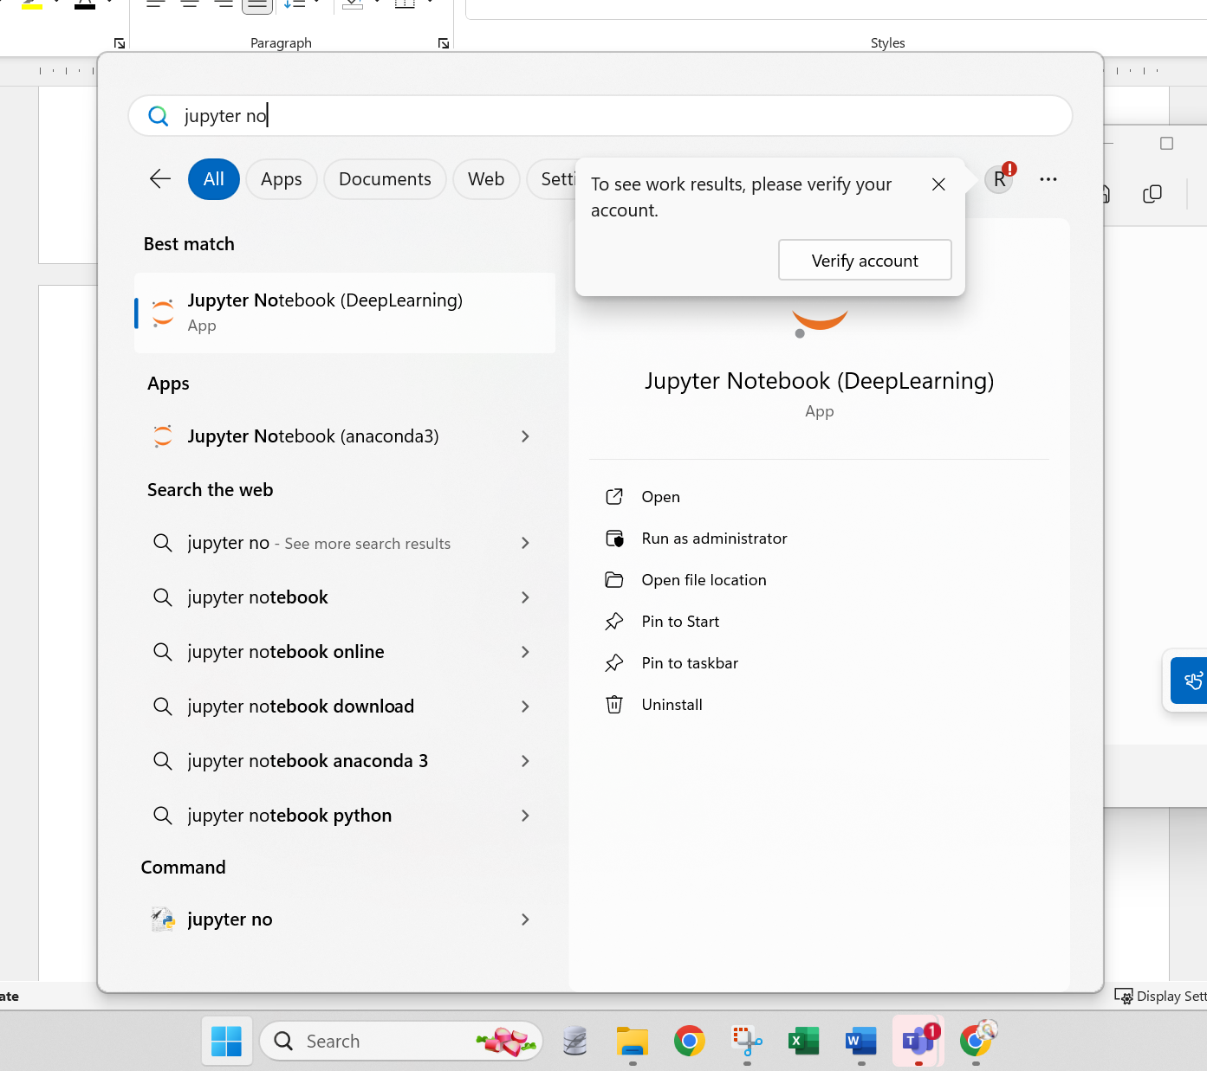

1. **The background kernel will start and Jupyter will launch in your default browser**

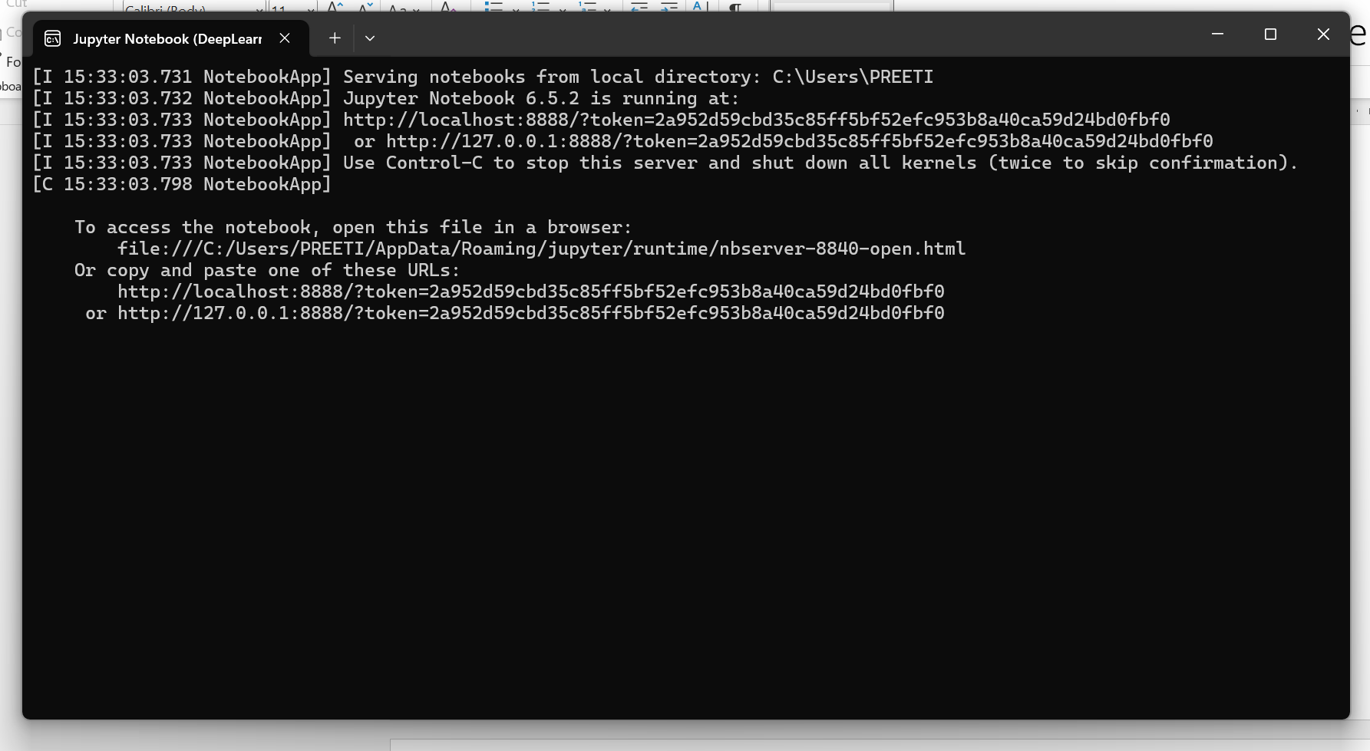

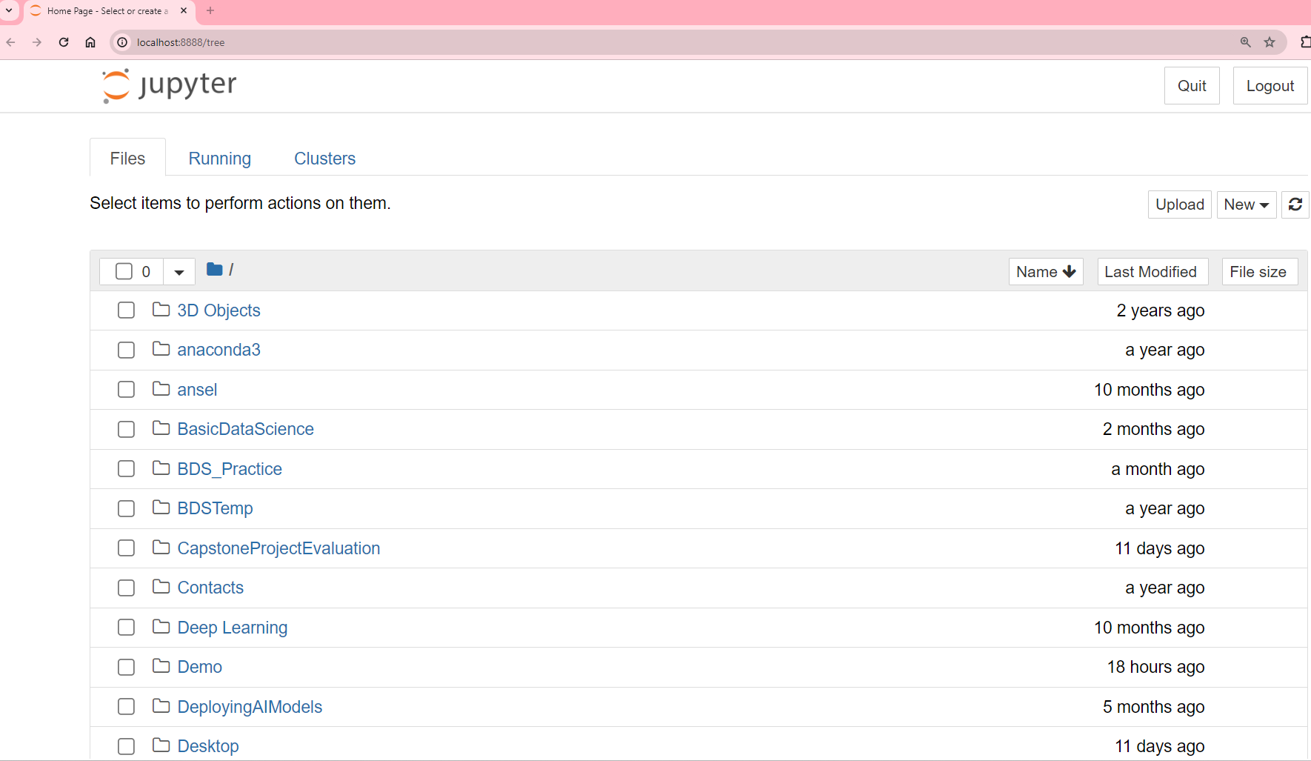

**Create Folder on Jupyter Notebook to keep your work organized**

1. **Click on New** 🡪 **Folder**

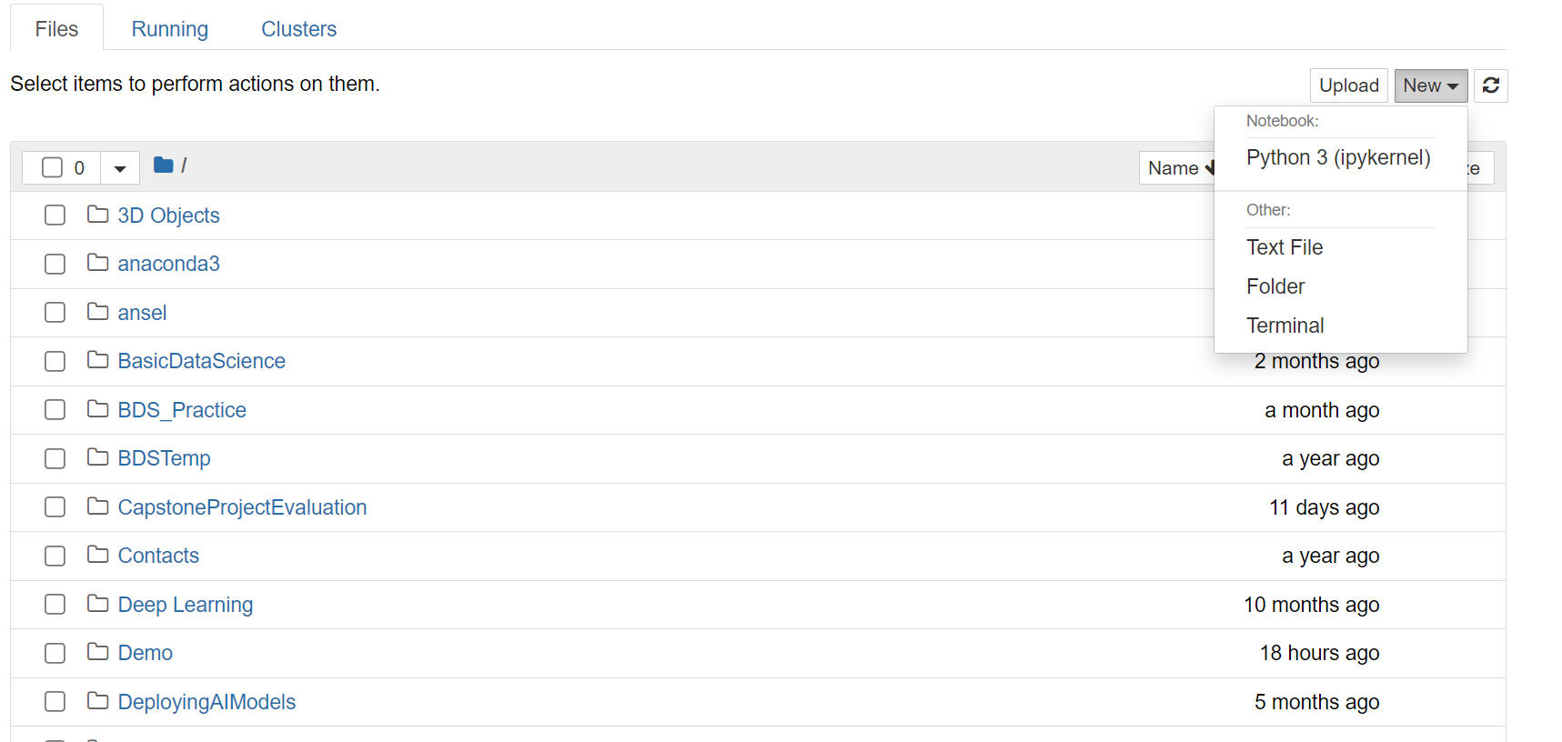

1. **An Untitled Folder will be created, click the checkbox next to it and select Rename button to rename this folder**

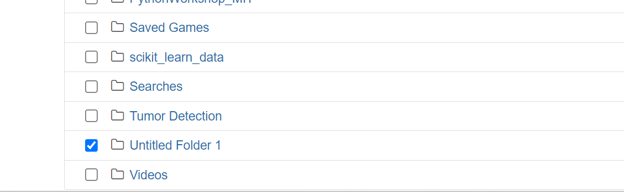

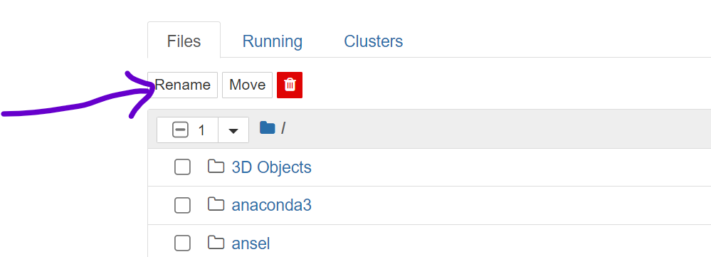

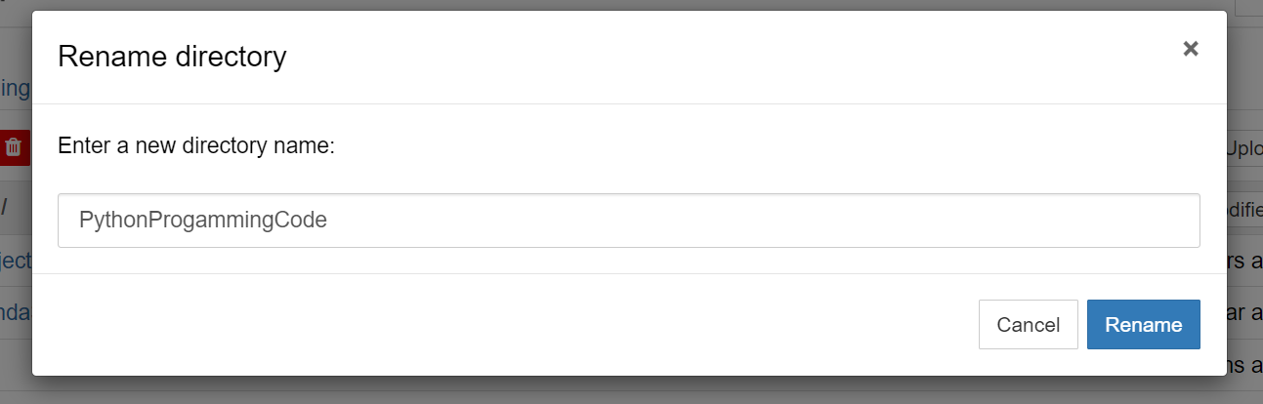

**Create new Notebook in the folder created**

1. **Click to open the folder you created; in very class you have to work on same folder.**

**You may create further subfolders within it to keep your work organized.**

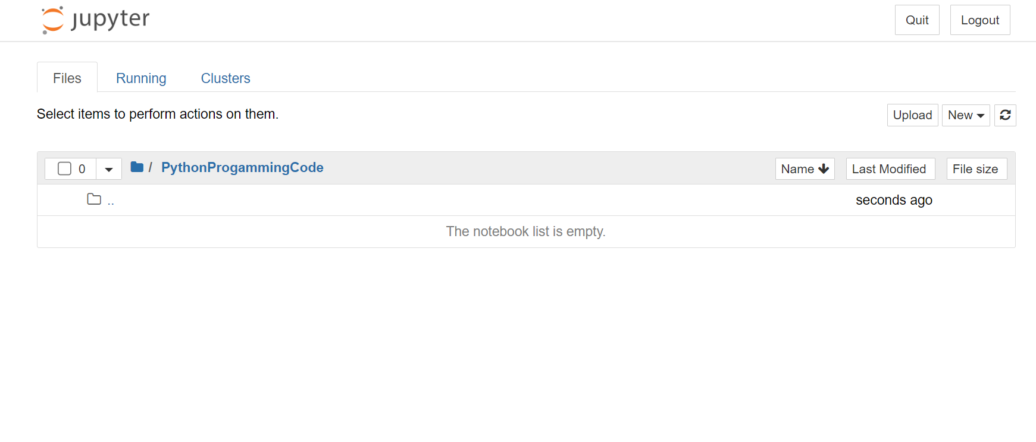

1. **Click the new🡪Notebook OR Python3(ipykernel) option**

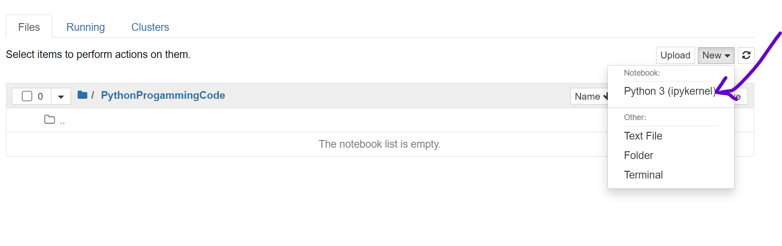

1. **In the new tab the Untitled-jupyter Notebook will open**

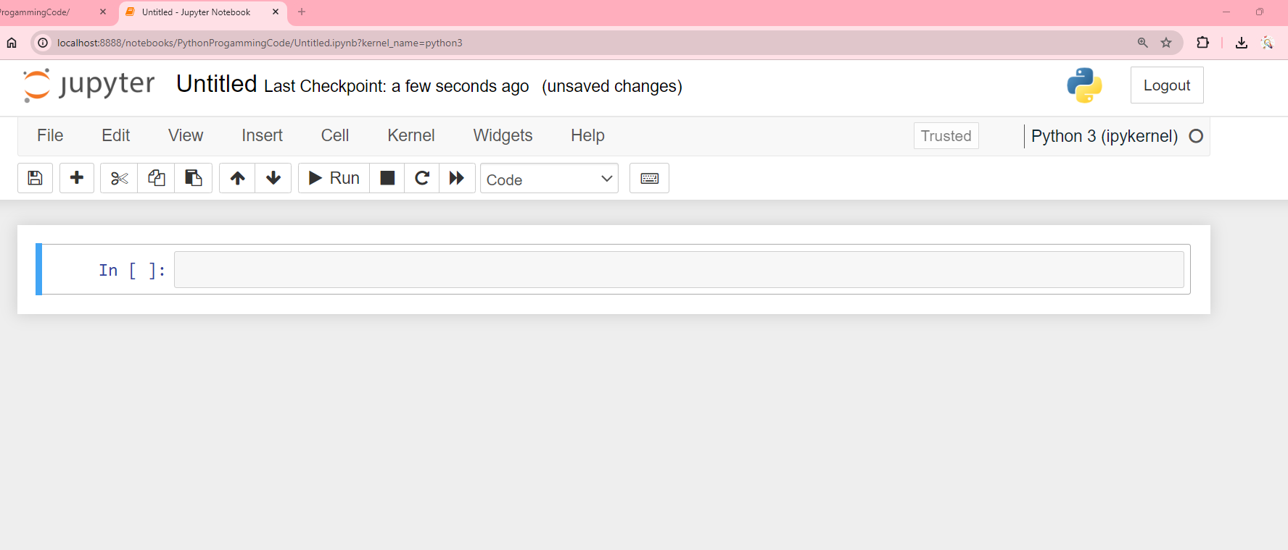

1. **Click on highlighted portion to rename the notebook**

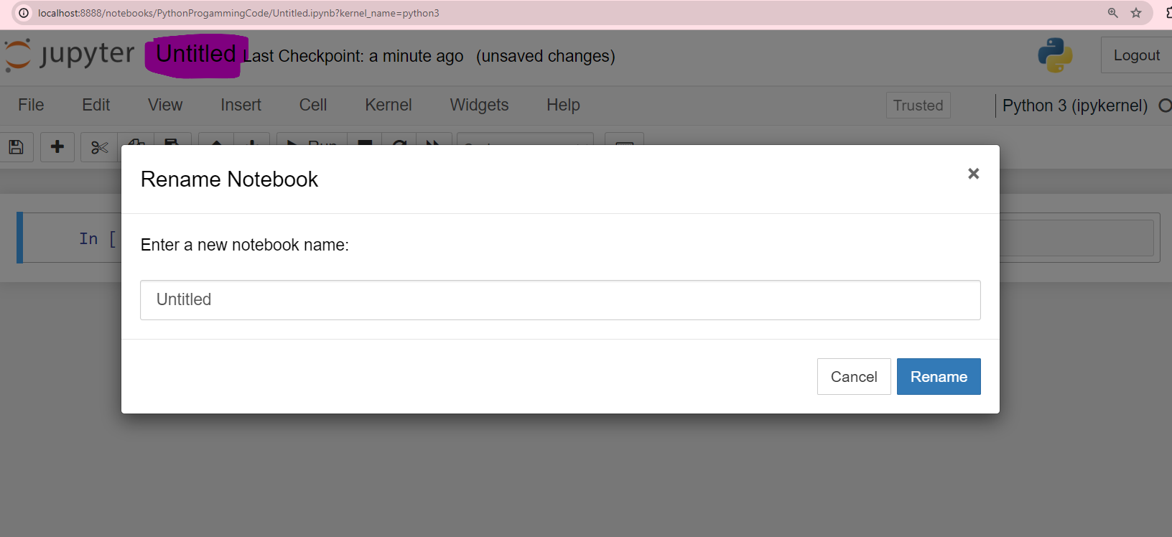

**Basic layout of Jupyter Notebook**

